INDIAN INSTITUTE OF INFORMATION TECHNOLOGY VADODARA
International Campus Diu · Department of Computer Science and Engineering
OBJECT-ORIENTED PROGRAMMING · PROJECT REPORT
FitMate
A cross-platform fitness and workout trainer built with object-oriented design

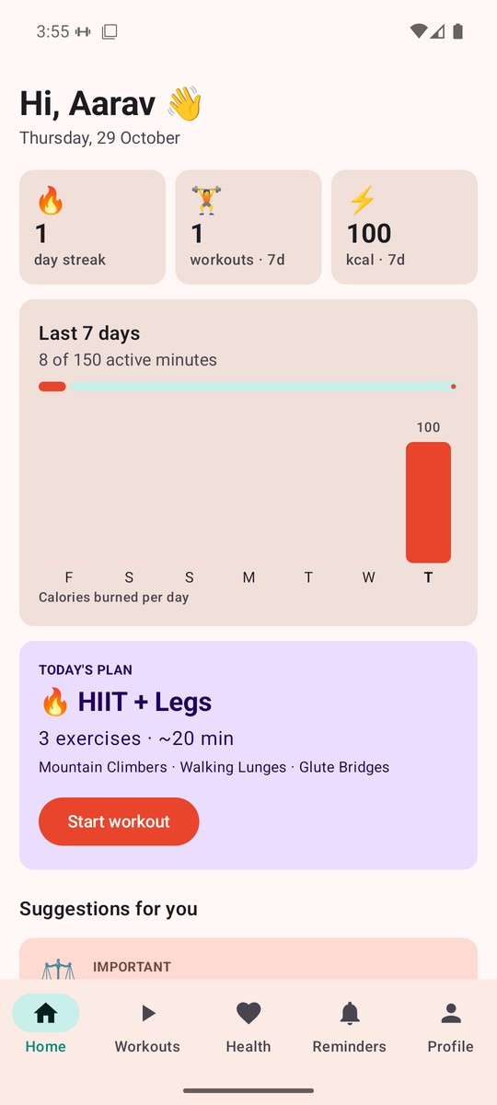 | 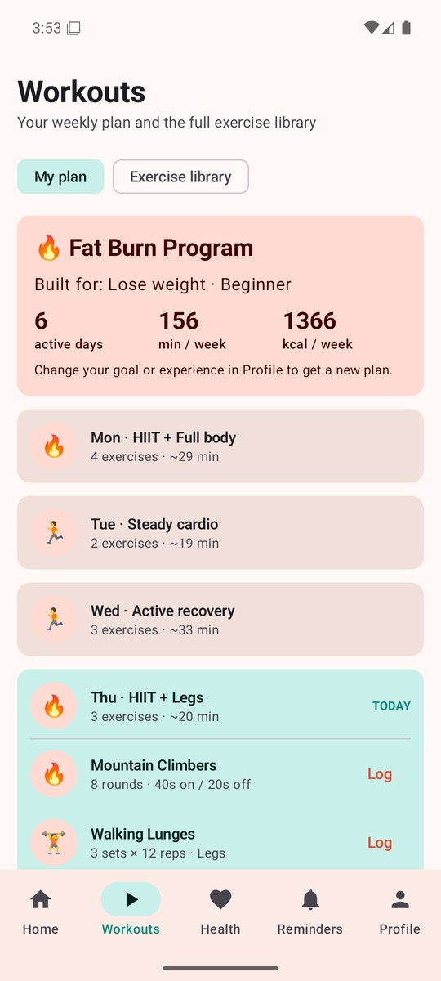 | 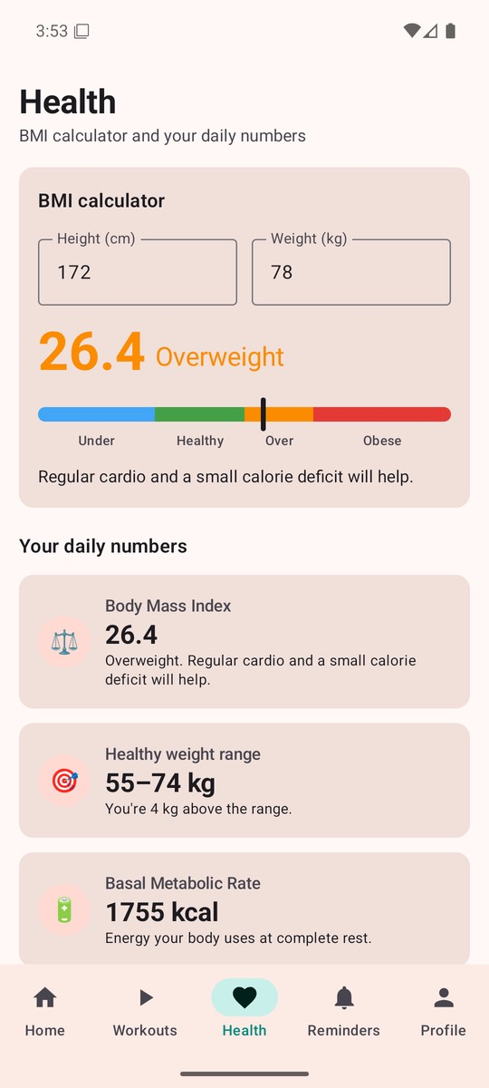

SUBMITTED BY | ROLL NUMBER
Shivang Raj | 20252501076
Bhumika Gupta | 20252501095
Vir Sharma | 20252501093
Deepansh Singh | 20252501019

Source code: github.com/shivang-raj/FitMate
November 2026

Abstract
FitMate is a fitness and workout trainer that runs on Android, iOS and desktop, with a small Python FastAPI service that finds exercise tutorial videos. A user enters their details once (age, height, weight, gender, activity level, goal and experience) and the app builds a seven-day workout plan, records completed workouts and the calories burned, works out health numbers such as BMI, BMR and a daily calorie target, gives personalised tips and sends daily reminders. There is no login: every piece of personal data stays on the user's device.
The project was built for the Object-Oriented Programming course, so the main aim was not just a working app but a clean object-oriented design. Every core OOP concept — classes and objects, encapsulation, inheritance, polymorphism, abstraction, interfaces, generics and composition — is used inside a real feature rather than a toy example. Six design patterns (Strategy, Factory, Singleton, Repository, Observer and Dependency Injection) keep the code easy to extend: adding a new fitness goal, health metric or suggestion rule means adding one new class without editing the screens.
The Android app is written in Kotlin with Jetpack Compose, the iOS app in Swift with SwiftUI, and the desktop app in Kotlin with Compose Desktop. Together the four parts contain about 8,800 lines of source code. Fourteen Android unit tests and five backend tests check the core logic.

Keywords
Object-oriented programming · Kotlin · Jetpack Compose · Swift · FastAPI · design patterns · fitness tracking · health metrics

Contents
Abstract 2
1 Introduction 4
2 Features 5
3 Technology Stack 6
4 System Architecture 7
5 Object-Oriented Concepts 9
6 Design Patterns 14
7 UML Diagrams 17
8 Application Screenshots 19
9 Testing 23
10 Installation and Running 24
11 Privacy and Security 25
12 Conclusion and Future Work 26
References 27

1 Introduction

1.1 Background
Many students and young adults want to exercise regularly but do not know where to start. Gym trainers cost money, generic online plans ignore a person's goal and fitness level, and most fitness apps ask for an account, show ads, or upload personal health data to a server. Beginners also struggle with form: doing a push-up or squat the wrong way can cause injury.
FitMate tries to solve these problems with one simple app. It asks for a few details, builds a plan that matches the user's goal, explains each exercise, plays a short tutorial video, and keeps track of progress — all without an account.

1.2 Problem statement
Design and build a fitness application that creates a personalised weekly workout plan, tracks workouts and calories, calculates key health numbers and reminds the user to stay active — and use the project to demonstrate every major object-oriented programming concept and common design patterns in real, working code.

1.3 Objectives
- Collect the user's profile once and reject invalid values (for example, an age of 5 or a weight of 500 kg).
- Generate a seven-day plan (Day 1 to Day 7) that depends on the user's goal and experience level.
- Provide an exercise library with clear instructions, grouped by type.
- Let the user log workouts, and estimate calories burned with a standard MET-based formula.
- Show progress: streak, seven-day chart, weekly minutes and calories.
- Calculate health numbers: BMI, healthy weight range, BMR, daily calories, protein and water.
- Send daily reminders for workouts, water, meals, stretching and sleep.
- Find and play the best tutorial video for each exercise.
- Apply all core OOP concepts and design patterns in a way that can be explained and tested.

1.4 Scope
Table 1.1 What the project covers
In scope | Out of scope
Android, iOS and desktop apps with the same core design | User accounts, login or cloud sync
Goal-based weekly plans for four goals and three levels | Diet plans or meal tracking
Local storage of profile, workout logs and reminders | Wearables and step counters
Tutorial search through a small FastAPI backend | Medical advice — health numbers are general guidance only

2 Features
The table below lists FitMate's main features, what each one does for the user, and the classes behind it. The numbers in the strip are taken from the source code.
23  exercises | 4  exercise types | 4  fitness goals | 6  health metrics | 6  suggestion rules | 5  reminder types

Table 2.1 Main features and the classes that implement them
Feature | What it does | Main classes
Profile | Stores name, age, height, weight, gender, activity level, goal and experience. Bad values are rejected with a clear message. | UserProfile
Weekly plan | Builds Day 1 to Day 7 for the chosen goal. Each day has a clear name, such as “Leg Day”, and Sunday is a rest day. | PlanStrategy, WorkoutPlanFactory, WorkoutPlan
Exercise library | 23 exercises in four groups — Strength, Cardio, HIIT and Flexibility — each with sets, reps or time and a form tip. | ExerciseLibrary, Exercise
Workout log | Records a finished exercise with its duration; calories are calculated automatically. | WorkoutLog, Repository<T>
Progress | Shows the current streak, a seven-day calorie chart, workouts and minutes this week. | WorkoutStats
Health | BMI calculator with category, healthy weight range, BMR, daily calories, protein and water. | HealthMetric + 6 metrics
Smart tips | Personal suggestions, sorted by priority, such as “Time to get moving” after two rest days. | SuggestionEngine, SuggestionRule
Tutorials | Finds and plays the best YouTube video for an exercise inside the app. | TutorialApiClient, FastAPI backend
Reminders | Daily notifications for workout, water, meal, stretch and sleep; restored after a phone restart. | Reminder, ReminderScheduler

3 Technology Stack
FitMate has four parts. The Android and desktop apps share the same Kotlin model and planner classes; the iOS app follows the same design in Swift. The backend is only used to search for tutorial videos, so the apps work offline for everything else.
Table 3.1 Platforms and tools
Part | Language | UI / framework | Notes
Android app | Kotlin | Jetpack Compose | Min SDK 26, target SDK 36; alarms and notifications
iOS app | Swift | SwiftUI | iOS 16 or later; same classes as Android
Desktop app | Kotlin | Compose Desktop | JCEF browser for playing tutorials
Backend | Python 3 | FastAPI, Uvicorn | YouTube Data API v3, SQLite for feedback
Build and tools | — | Gradle, Xcode, pip | Git and GitHub for version control

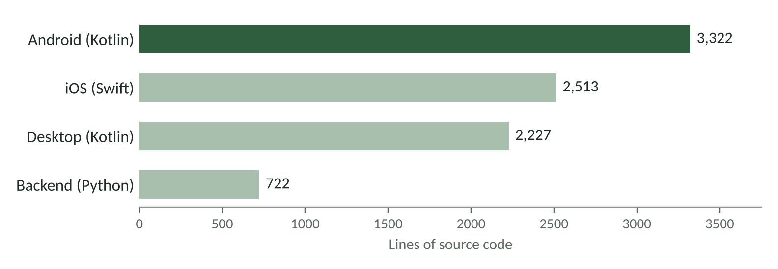
Figure 3.1 Size of each part of the project, in lines of source code

4 System Architecture

4.1 Layered design
The Android app is split into layers. Screens only draw the interface and pass user actions to FitnessViewModel. The view model holds the app's state and calls the logic classes, the storage classes and the tutorial client. Because the screens never talk to storage or alarms directly, either of these can be replaced without touching the UI.
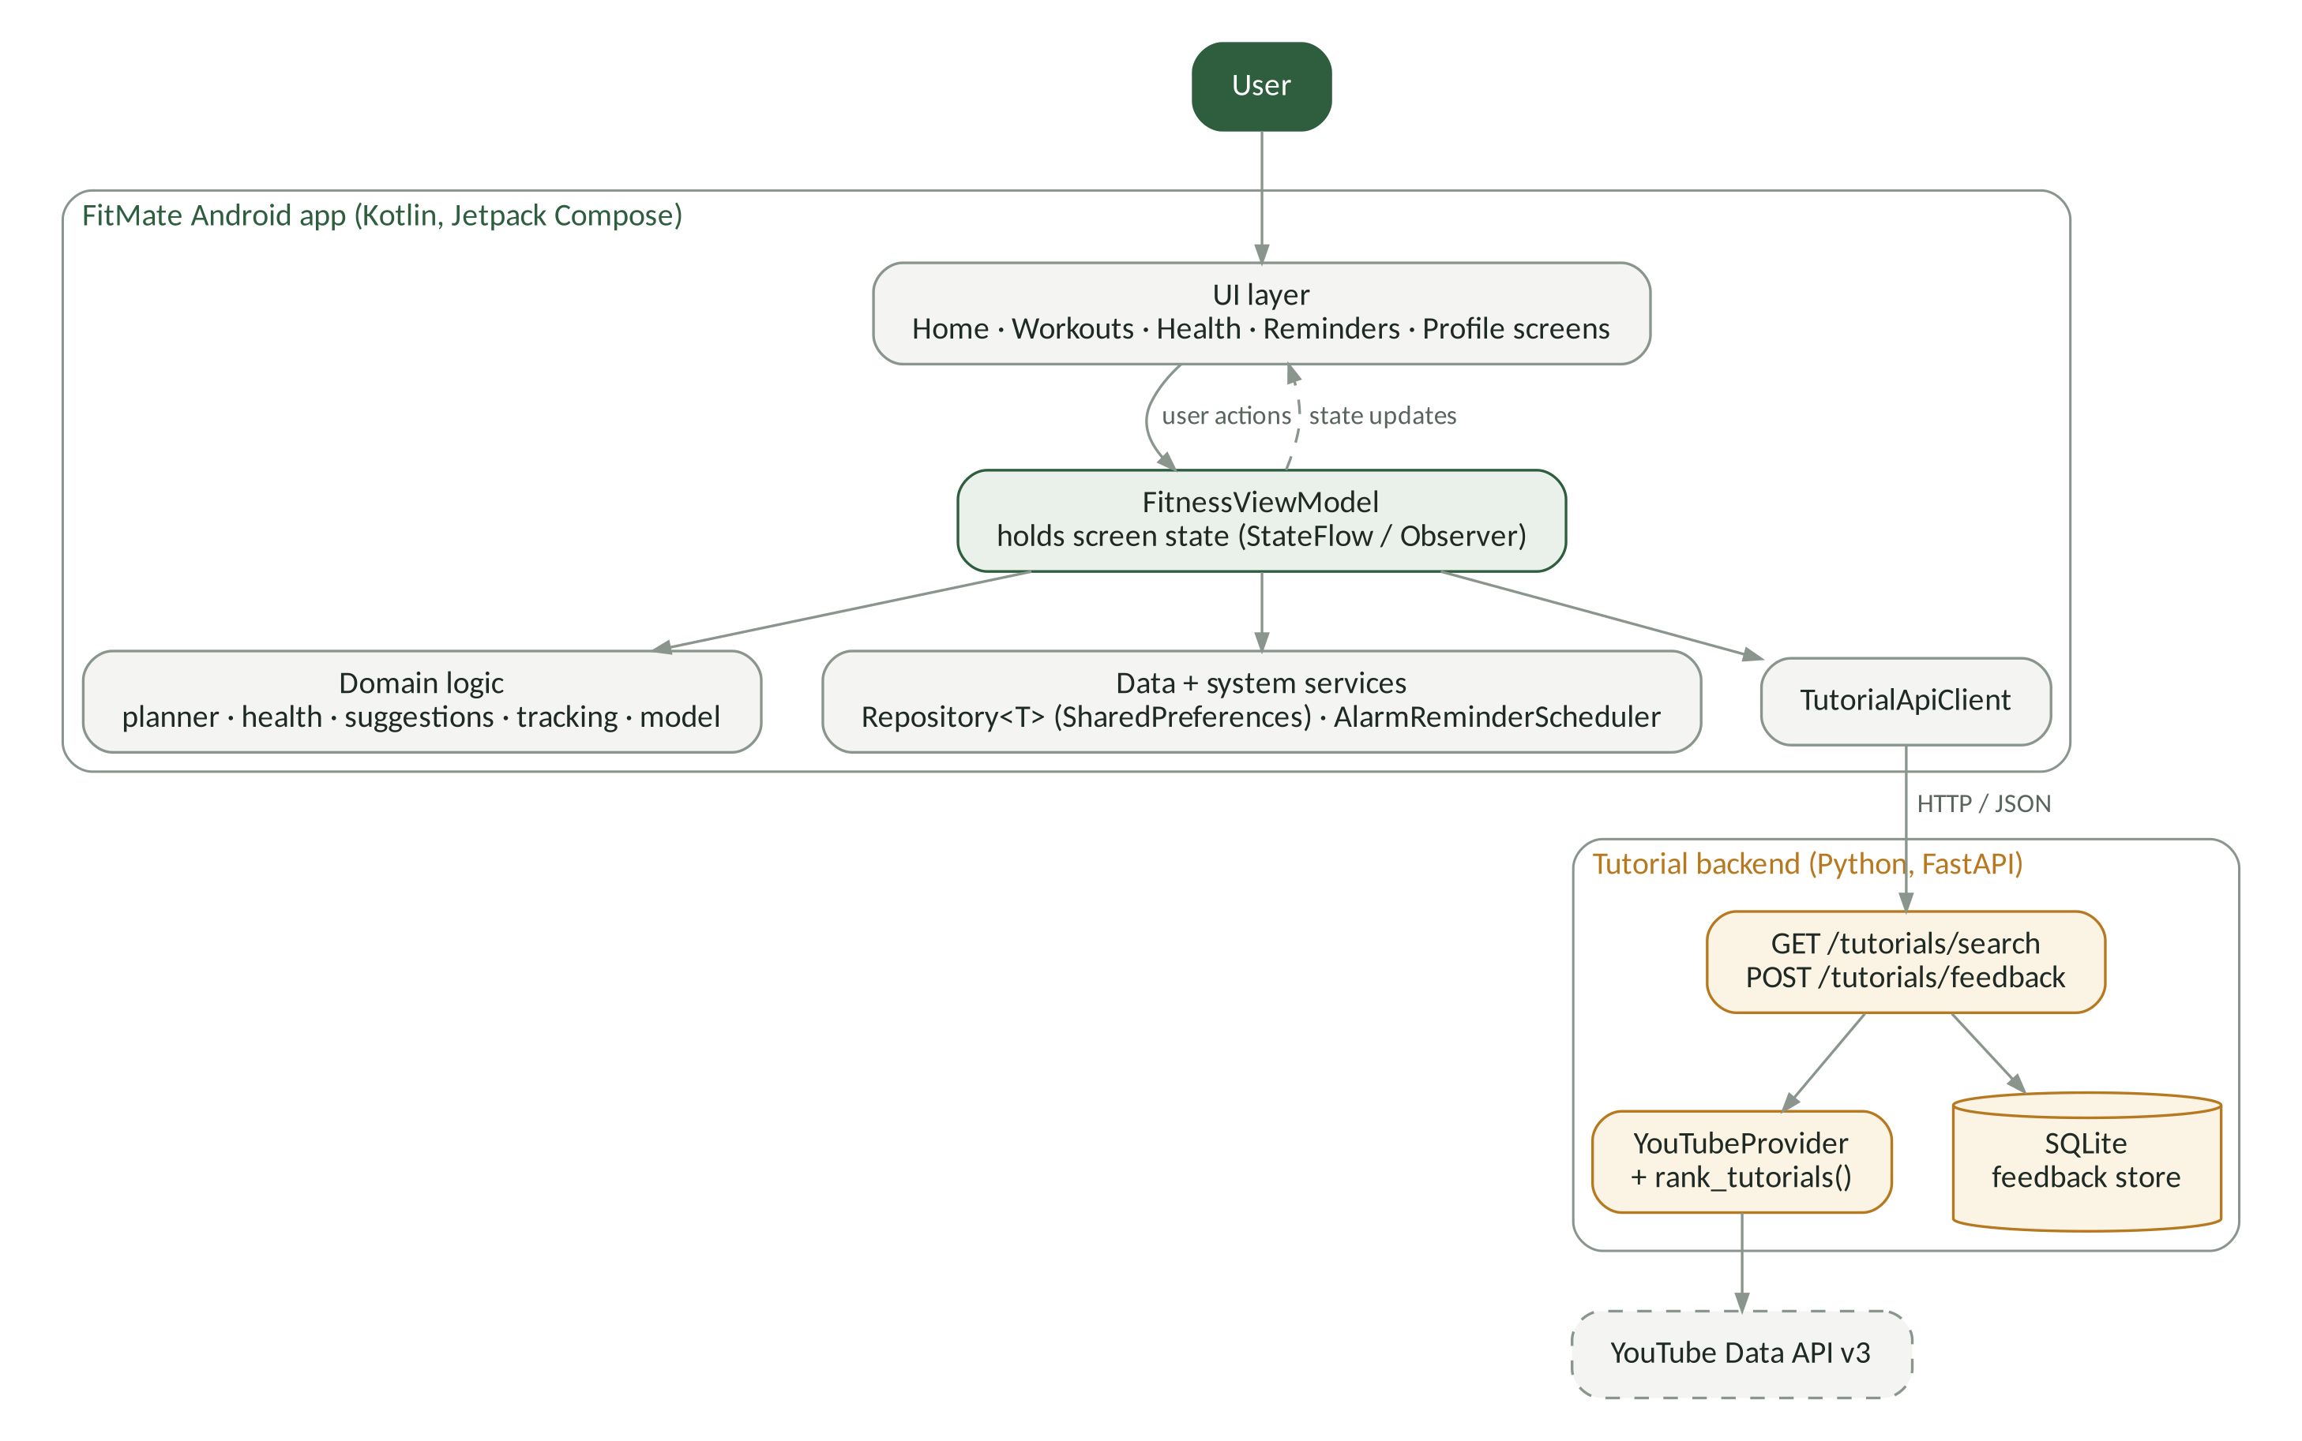
Figure 4.1 Architecture of the Android app and the tutorial backend
Table 4.1 Packages and their responsibilities
Package | Responsibility | Key classes
model | Domain data | Exercise + 4 subclasses, UserProfile, WorkoutPlan, WorkoutLog, Reminder, enums
planner | Builds the weekly plan | PlanStrategy, BasePlanStrategy, 4 strategies, WorkoutPlanFactory
health | Health calculations | HealthMetric + 6 metrics
suggestions | Personal tips | SuggestionEngine, SuggestionRule + 6 rules
tracking | Weekly statistics | WorkoutStats
data | Saving and loading | Repository<T>, PrefsRepository<T>, JsonMapper<T>
reminders | Alarms and notifications | ReminderScheduler, AlarmReminderScheduler
viewmodel / ui | Screen state and screens | FitnessViewModel, Compose screens

4.2 How a user moves through the app
Each step of the user's journey is handled by its own class. This is the single-responsibility principle in practice.
Table 4.2 User journey and the class in charge of each step
Step | What happens | Class in charge
1. Create profile | User enters details; each value is checked before it is saved. | UserProfile
2. Weekly plan | The factory picks the plan class for the goal and builds seven days. | PlanStrategy
3. Log a workout | User logs an exercise; calories are worked out from its own formula. | WorkoutLog
4. Health and tips | Metrics and rules run on the profile and the workout history. | HealthMetric
5. Reminders | Daily alarms are scheduled and shown as notifications. | ReminderScheduler

4.3 Tutorial search
When the user taps Watch tutorial, the app sends the exercise name to the backend. The backend searches YouTube, removes videos that cannot be embedded or are not relevant, scores the rest and returns the best one, which then plays inside the app.
Figure 4.2 Steps from tapping “Watch tutorial” to playing a video
rank_tutorials() gives each video a score between 0 and 1 using four weighted signals. Videos with a relevance below 0.30, videos that cannot be embedded, and videos the user has rejected before are skipped. If a signal is missing (for example, a hidden like count), the remaining weights are rescaled so the ranking still works.
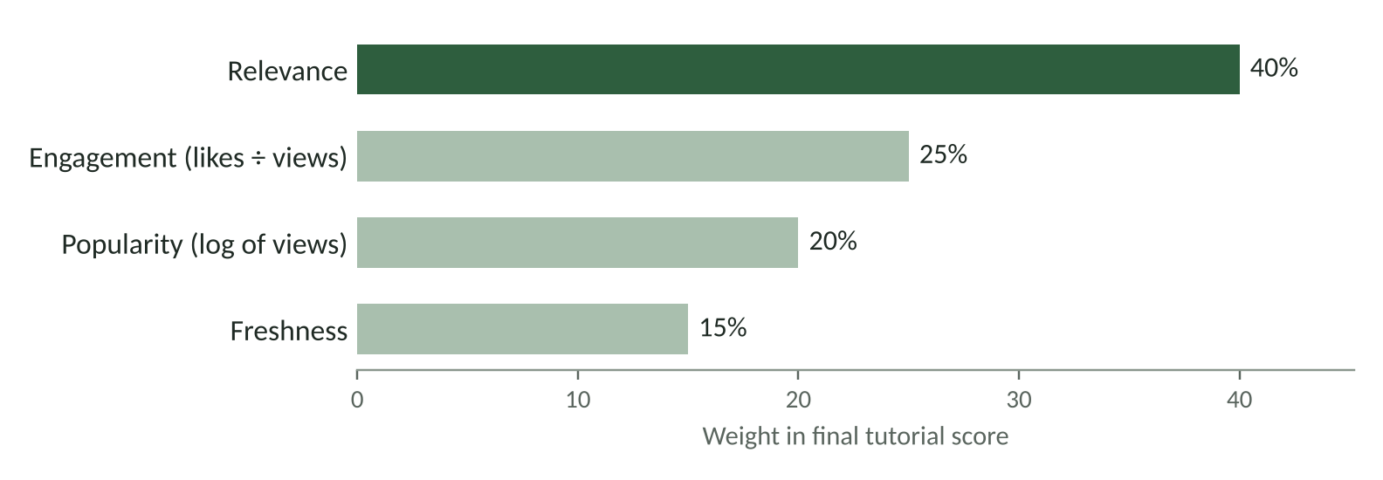
Figure 4.3 Weights used to score a tutorial video

5 Object-Oriented Concepts
This chapter shows where each OOP concept is used in FitMate. All code is taken from the Android app; the desktop app reuses the same classes and the iOS app mirrors them in Swift.
Table 5.1 Summary of OOP concepts in FitMate
Concept | Where it is used | Class
Class and object | Each workout the user logs is a new object | WorkoutLog
Encapsulation | The profile checks its own values before saving them | UserProfile
Inheritance | All exercise types reuse one parent class | Exercise
Polymorphism | Each exercise type counts time and calories its own way | caloriesBurned()
Abstraction | Screens use a health metric without knowing its formula | HealthMetric
Interface | Every plan class has the same buildPlan() method | PlanStrategy
Generics | One storage class saves both workouts and reminders | Repository<T>
Composition | A plan has 7 sessions; each session has exercises | WorkoutPlan

5.1 Classes and objects
A class is a blueprint and an object is one instance of it. FitMate has about 67 classes, interfaces, enums and objects. WorkoutLog is a Kotlin data class, so the compiler generates equals(), hashCode(), toString() and copy(). Its companion function from() builds a log from any kind of exercise.
model/WorkoutLog.kt
data class WorkoutLog(
override val id: String = UUID.randomUUID().toString(),
val exerciseName: String, val category: ExerciseCategory,
val minutes: Int, val calories: Double,
val timestamp: Long = System.currentTimeMillis()
) : Identifiable, Describable {
companion object {
// Factory method: works for ANY Exercise subclass
fun from(exercise: Exercise, minutes: Int, weightKg: Double) =
WorkoutLog(exerciseName = exercise.name, category = exercise.category,
minutes = minutes,
calories = exercise.caloriesBurned(weightKg, minutes))
}
}

5.2 Encapsulation
UserProfile never stores an impossible value. Its numeric fields can only be changed through setters that check the range first and throw an IllegalArgumentException if the value is wrong. The constructor values also go through the same setters in the init block, so a profile is valid both when it is created and every time it is changed. BMI is a read-only computed property, so it can never be out of date.
model/UserProfile.kt
var age: Int = 0
set(value) {
require(value in MIN_AGE..MAX_AGE) { "Age must be $MIN_AGE-$MAX_AGE" }
field = value
}

init { // constructor values go through the same setters
this.name = name; this.age = age
this.heightCm = heightCm; this.weightKg = weightKg
}

val bmi: Double
get() = weightKg / ((heightCm / 100) * (heightCm / 100))

Table 5.2 Validation rules in UserProfile
Field | Allowed range | Message shown if invalid
Name | Not blank | Name can't be empty
Age | 10 – 100 years | Age must be between 10 and 100
Height | 80 – 250 cm | Height must be between 80 and 250 cm
Weight | 20 – 300 kg | Weight must be between 20 and 300 kg

5.3 Inheritance and polymorphism
Exercise is an abstract class that holds the data every exercise shares: id, name, description, difficulty and MET value (how many times resting energy the activity burns). It cannot be created directly. Four subclasses add their own fields and their own way of working out the time. HiitExercise extends CardioExercise, which is multi-level inheritance.
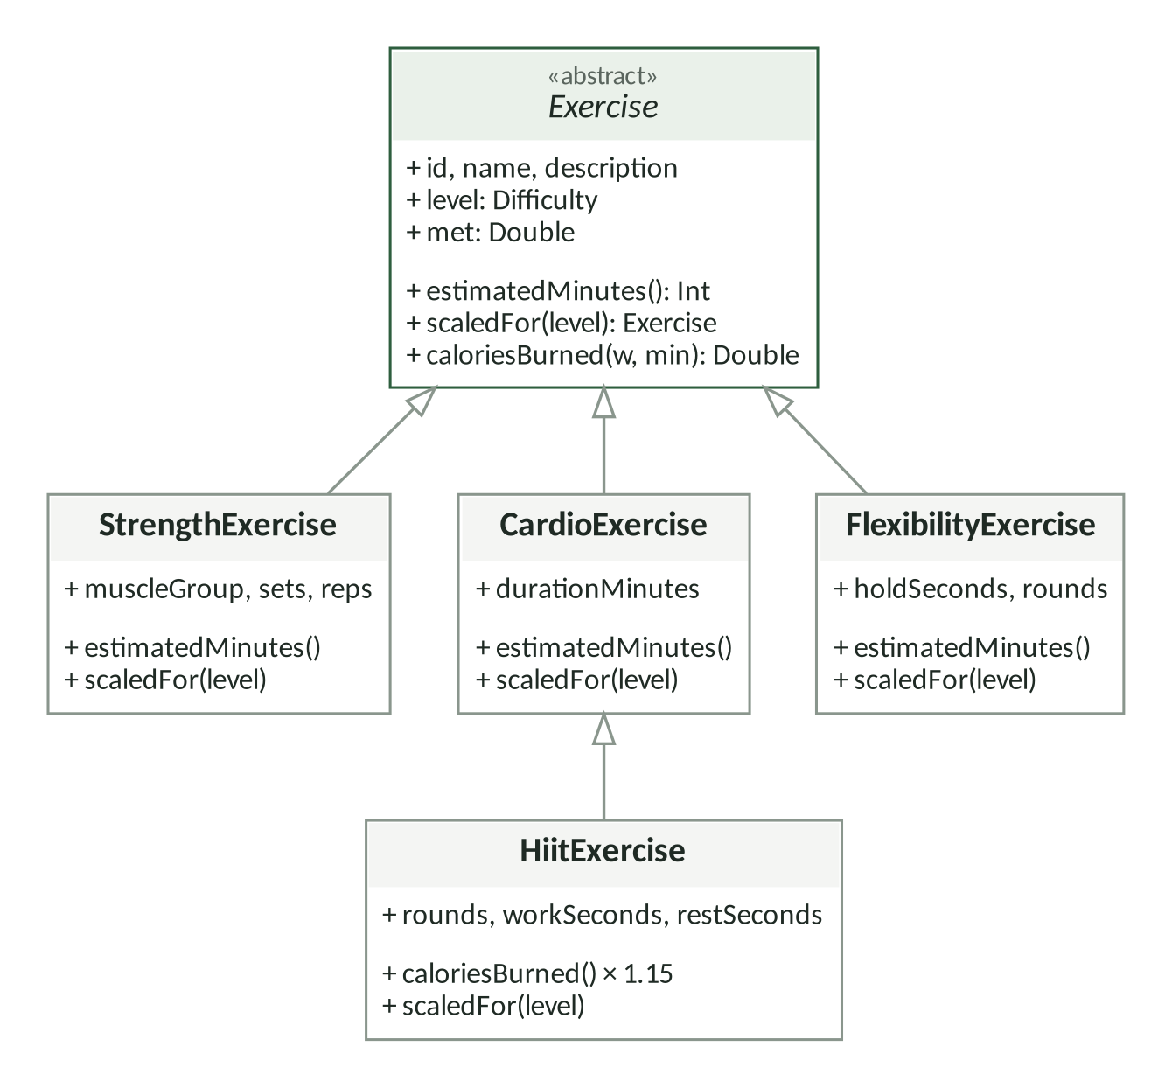
Figure 5.1 Exercise class hierarchy
The app always treats exercises as plain Exercise objects. When it calls estimatedMinutes() or caloriesBurned(), Kotlin runs the version that belongs to the real subclass at run time. This is runtime polymorphism (method overriding).
Table 5.3 How each exercise type works out its time and calories
Type | Estimated time | Calories | Example
Strength | 4 s per rep + 90 s rest between sets | MET × 3.5 × kg ÷ 200 × min | Push-ups, 3 × 12 → 6 min
Cardio | Fixed duration | MET × 3.5 × kg ÷ 200 × min | Running, 20 min
HIIT | rounds × (work + rest) | Parent formula × 1.15 (afterburn) | Mountain climbers, 8 rounds → 8 min
Flexibility | hold × rounds × 2 sides | MET × 3.5 × kg ÷ 200 × min | Cobra stretch, 20 s × 4

model/Exercise.kt — HiitExercise reuses its parent's formula with super
override fun caloriesBurned(weightKg: Double, minutes: Int): Double =
super.caloriesBurned(weightKg, minutes) * AFTERBURN_BONUS // 1.15

Worked example
For a 78 kg user doing 8 minutes of mountain climbers (MET 8.0): 8.0 × 3.5 × 78 ÷ 200 × 8 = 87.4 kcal; with the 15% HIIT bonus this becomes ≈ 100 kcal, which is exactly what the Android app shows in Figure 8.1.

5.4 Abstraction and interfaces
HealthMetric is an interface with calculate(), interpret() and a default formatted() method. The Health screen loops over a list of six metrics and never needs to know which formula it is drawing. A new metric can be added by writing one class and adding it to the list.
health/HealthMetric.kt
interface HealthMetric {
val name: String
fun calculate(profile: UserProfile): Double
fun interpret(profile: UserProfile): String
fun formatted(profile: UserProfile): String = "%.1f".format(calculate(profile))
}
class BmiMetric : HealthMetric { ... }

Table 5.4 The six health metrics and a worked example (female, 20 years, 166 cm, 68 kg, sedentary, “Stay fit”)
Metric | Formula | Result
Body Mass Index | weight ÷ height² | 24.7 — Healthy
Healthy weight range | BMI 18.5 to 24.9 at the user's height | 51 – 69 kg
Basal Metabolic Rate | Mifflin–St Jeor: 10w + 6.25h − 5a + s (s = +5 male, −161 female) | 1,457 kcal
Daily calories | BMR × activity factor (1.2 – 1.9) + goal change (−500 / +300 / 0) | 1,748 kcal
Daily protein | 1.2 – 1.8 g per kg, depending on goal | 82 g
Daily water | 0.033 L per kg, + 0.5 L if very active | 2.2 L

The BMI value in this example matches the desktop Profile screen (Figure 8.6). DailyCaloriesMetric also shows composition: it holds a BmrMetric object and reuses its formula instead of copying it.

5.5 Generics
Workout logs and reminders are both saved as JSON in the phone's SharedPreferences. Instead of writing two storage classes, FitMate uses one generic Repository<T>. The type parameter is bounded by Identifiable, so every stored item is guaranteed to have an id. The type-specific JSON conversion is passed in as a JsonMapper<T>.
data/Repository.kt
interface Repository<T : Identifiable> {
fun getAll(): List<T>
fun save(item: T) // insert, or replace the item with the same id
fun delete(id: String)
}

// AppContainer: one generic class, two different types
val workoutRepository: Repository<WorkoutLog> =
PrefsRepository(prefs, "workout_logs", WorkoutLogMapper)
val reminderRepository: Repository<Reminder> =
PrefsRepository(prefs, "reminders", ReminderMapper)

Generics are also used in ExerciseLibrary.ofType<T>(). Calling ofType<CardioExercise>() returns cardio and HIIT exercises, because a HiitExercise is a CardioExercise.

5.6 Composition
A WorkoutPlan has seven WorkoutSession objects, and each session has a list of exercises. The plan's totals are built from its parts: weekly minutes is the sum of each session's minutes, and each session asks every exercise for its own calories.
model/WorkoutPlan.kt
class WorkoutPlan(val name: String, val goal: FitnessGoal,
val level: Difficulty, val sessions: List<WorkoutSession>) {
val activeDays: Int get() = sessions.count { !it.isRestDay }
val weeklyMinutes: Int get() = sessions.sumOf { it.totalMinutes() }
}

5.7 Other features of the language
Table 5.5 Additional OOP features used
Feature | Use in FitMate
Enums as classes | ActivityLevel carries its multiplier; BmiCategory.from(bmi) picks the right category.
Companion objects (static members) | Validation limits such as MIN_AGE and factory methods like WorkoutLog.from().
Operator overloading | ExerciseLibrary["squats"] looks up an exercise by id.
Immutability | Reminder is a data class; changes are made with copy().
Visibility modifiers | protected helpers in BasePlanStrategy; private fields in repositories.

6 Design Patterns
Design patterns are reusable solutions to common design problems. FitMate uses six of them, plus the Template Method pattern inside the planner.
Table 6.1 Design patterns used in FitMate
Pattern | Where | Why it helps
Strategy | One plan class per goal | The plan algorithm can change without changing the code that uses it.
Factory | WorkoutPlanFactory | Callers ask for a plan and never need to know which class builds it.
Template Method | BasePlanStrategy | Fixes the steps once; subclasses only fill in the weekly schedule.
Singleton | ExerciseLibrary (object) | The whole app reads from one shared exercise catalogue.
Repository | Repository<T> | Hides how and where data is stored.
Observer | StateFlow in FitnessViewModel | Screens redraw automatically when the data changes.
Dependency Injection | AppContainer | Creates shared objects once and hands them out as interfaces.

6.1 Strategy and Factory: building the weekly plan
Each fitness goal has its own plan class. All four extend BasePlanStrategy, which implements the PlanStrategy interface. buildPlan() is marked final: it always gets the schedule, scales each exercise to the user's level and numbers the days 1 to 7. Subclasses can only decide which exercises go on which day.
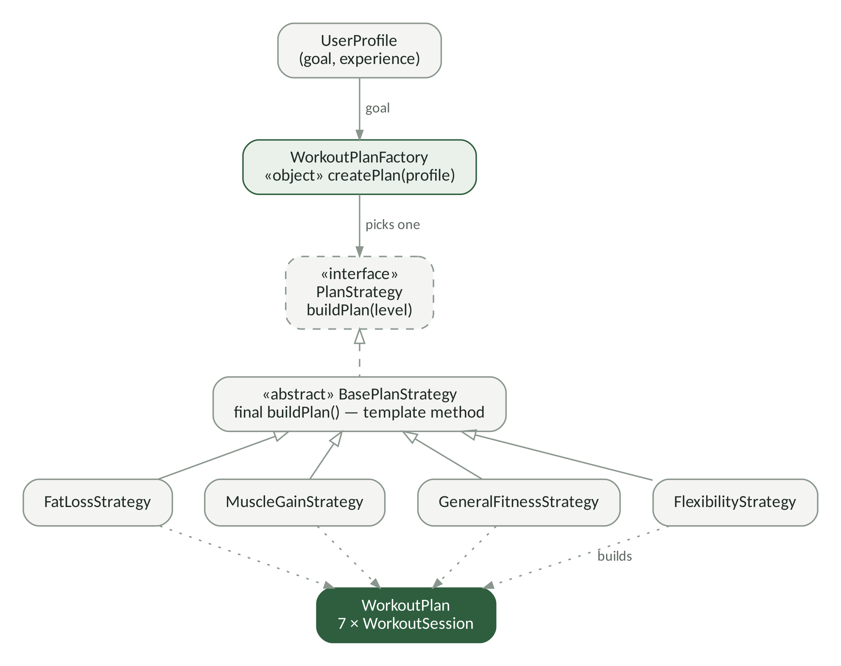
Figure 6.1 Strategy and Factory patterns in the planner
planner/PlanStrategy.kt
object WorkoutPlanFactory {
fun strategyFor(goal: FitnessGoal): PlanStrategy = when (goal) {
LOSE_WEIGHT -> FatLossStrategy()
BUILD_MUSCLE -> MuscleGainStrategy()
STAY_FIT -> GeneralFitnessStrategy()
IMPROVE_FLEXIBILITY -> FlexibilityStrategy()
}
fun createPlan(profile: UserProfile): WorkoutPlan =
strategyFor(profile.goal).buildPlan(profile.experience)
}

Table 6.2 The four plans generated by the strategies
Goal | Plan name | Week (Day 1 → Day 6, Day 7 is rest)
Lose weight | Fat Burn Program | Full-Body HIIT · Cardio · Leg · Upper-Body · Tabata · Recovery Yoga
Build muscle | Push / Pull / Legs | Chest · Back · Leg · Shoulder · Full-Body · Mobility
Stay fit | Balanced Fitness | Full-Body · Cardio · Yoga · HIIT · Core & Cardio · Legs & Walk
Flexibility | Mobility & Yoga | Yoga · Hips · Full Stretch · Core · Yoga Flow · Stretch & Cycle

The experience level then changes the volume. An intermediate user gets one extra set on strength exercises and an advanced user gets two; cardio time is multiplied by 0.8, 1.0 or 1.3.

6.2 Open/closed suggestion rules
SuggestionEngine holds a list of SuggestionRule objects. Each rule looks at the profile and workout stats and either returns a tip or null. The engine collects the tips and sorts them by priority. A new tip is added by writing one new rule class — the engine itself never changes. This follows the open/closed principle: open for extension, closed for modification.
Table 6.3 Suggestion rules
Rule | When it fires | Example tip
InactivityRule | No workout yet, or 2+ days since the last one | “Time to get moving”
BmiRule | Always; advice depends on the BMI category | “Healthy BMI”
GoalRule | Always; advice depends on the goal | “Protein + progressive overload”
WeeklyTargetRule | Compares weekly minutes with the 150-minute WHO guideline | “30 min to your weekly goal”
RecoveryRule | Trained on 6 or more of the last 7 days | “Schedule a rest day”
HydrationRule | Always | “Stay hydrated” with the daily water target

7 UML Diagrams

7.1 Use case diagram
The user is the main actor. Two external systems support the app: the tutorial backend (with YouTube) and the phone's operating system, which fires alarms and restarts them after the phone reboots.
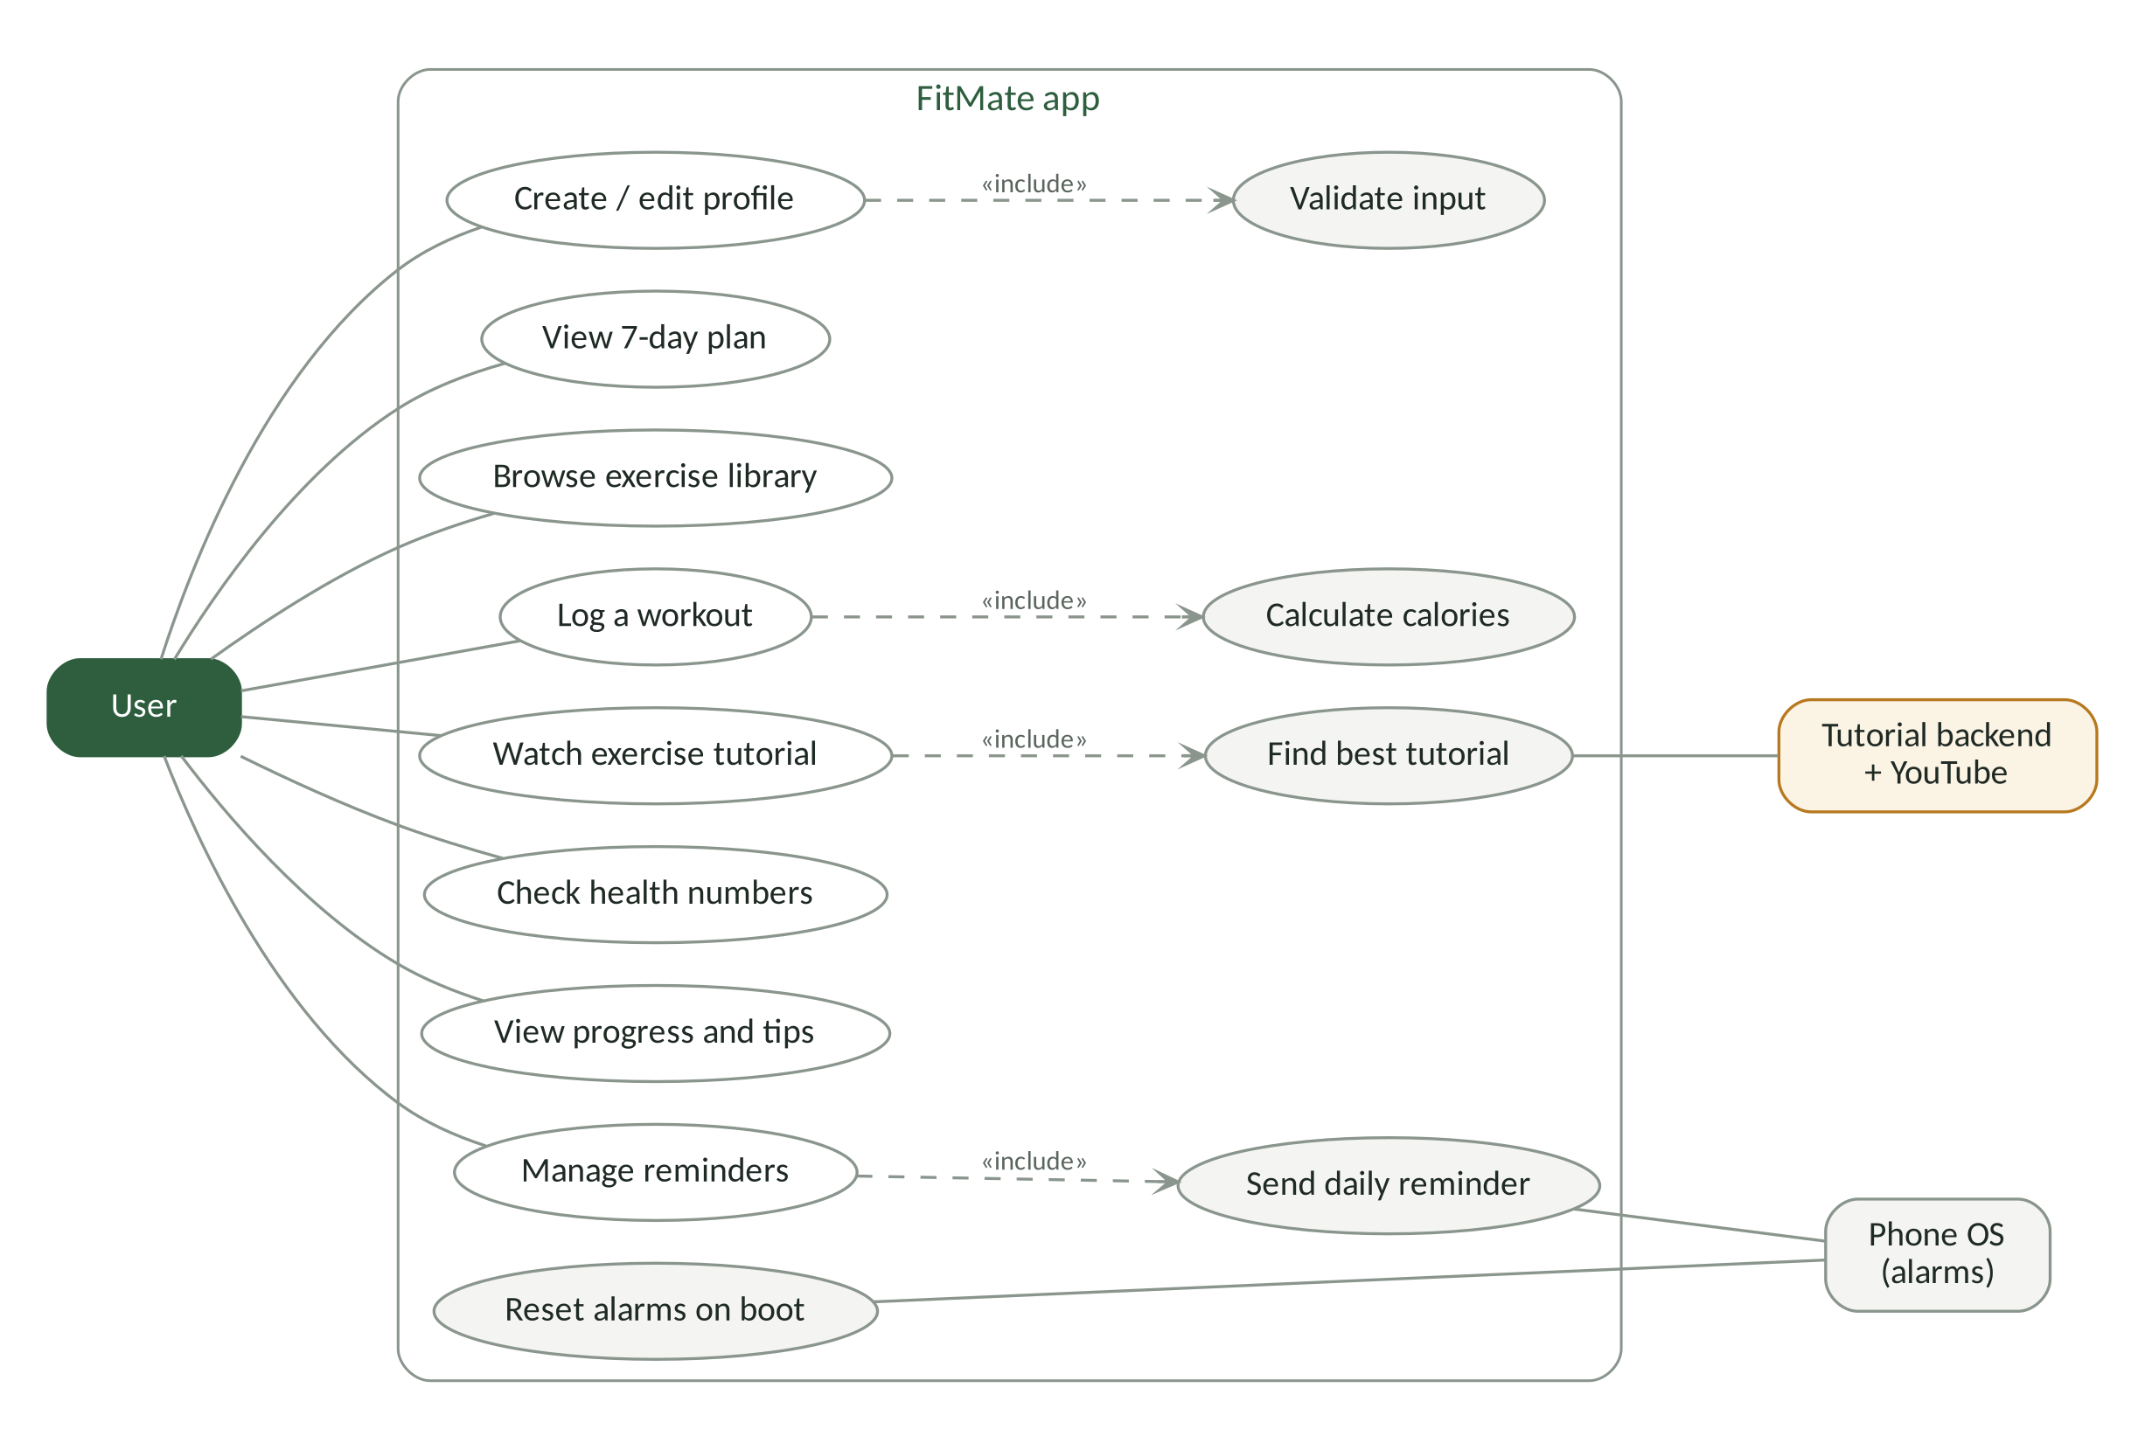
Figure 7.1 Use case diagram of FitMate

7.2 Class diagram
The simplified class diagram below shows the main classes and how they relate. FitnessViewModel sits at the centre and depends on interfaces, not concrete classes. Filled diamonds show composition, hollow diamonds show aggregation and hollow triangles show inheritance or interface implementation. The full diagram, with every field and method, is in the repository at docs/oop/class_diagram.png.
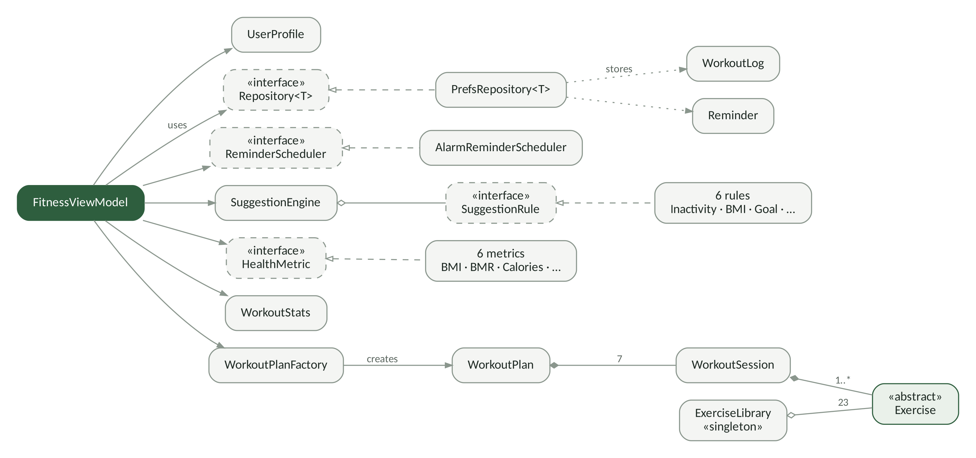
Figure 7.2 Simplified class diagram of the Android app
Table 7.1 How to read the relationships in the diagram
Relationship | Line in the diagram | Example in FitMate
Association (uses) | Solid line with an open arrow | FitnessViewModel uses SuggestionEngine
Inheritance / implementation | Hollow triangle (dashed for an interface) | PrefsRepository<T> implements Repository<T>
Composition | Filled diamond on the owner | WorkoutPlan owns 7 WorkoutSession objects
Aggregation | Hollow diamond on the container | ExerciseLibrary holds 23 Exercise objects
Dependency | Dotted line with an arrow | PrefsRepository<T> stores WorkoutLog and Reminder

8 Application Screenshots

8.1 Android app
The Android app has five tabs — Home, Workouts, Health, Reminders and Profile — and a one-time onboarding screen. These screenshots are taken from the project repository.
Figure 8.1 Android app screens
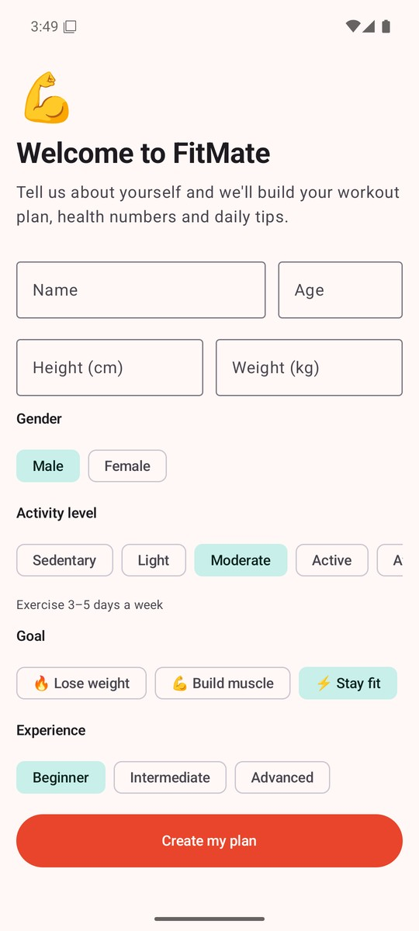  Onboarding  Profile is entered once | Home  Streak, 7-day chart, today's plan | Workouts  Goal-based weekly plan | 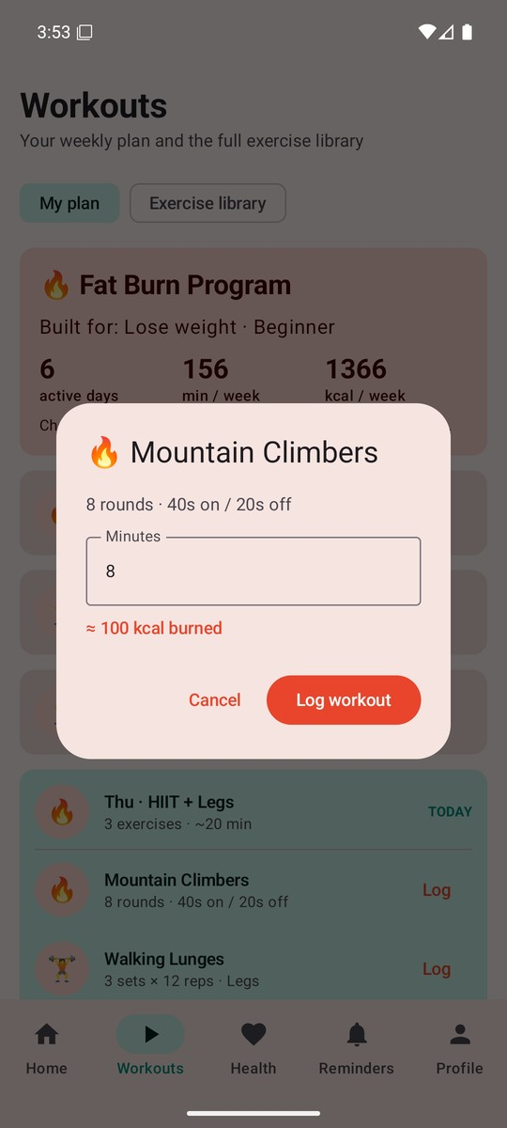  Log workout  Calories worked out for you
Health  BMI calculator and daily numbers | 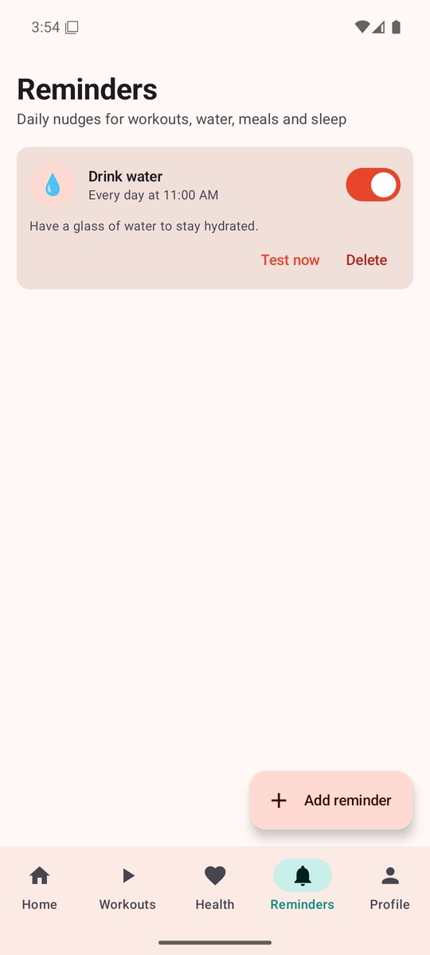  Reminders  Daily nudges with a test button | 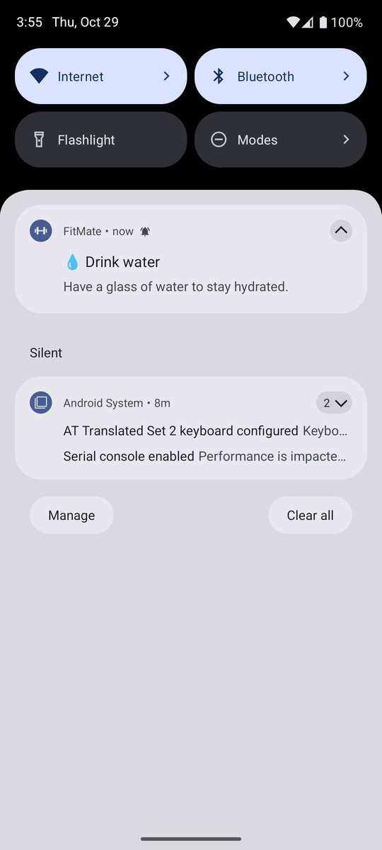  Notification  Reminder shown by the system

8.2 Desktop app
The desktop app uses the same model and planner classes as Android, with a sidebar layout that suits a larger screen. Tutorials play inside the app through an embedded browser.
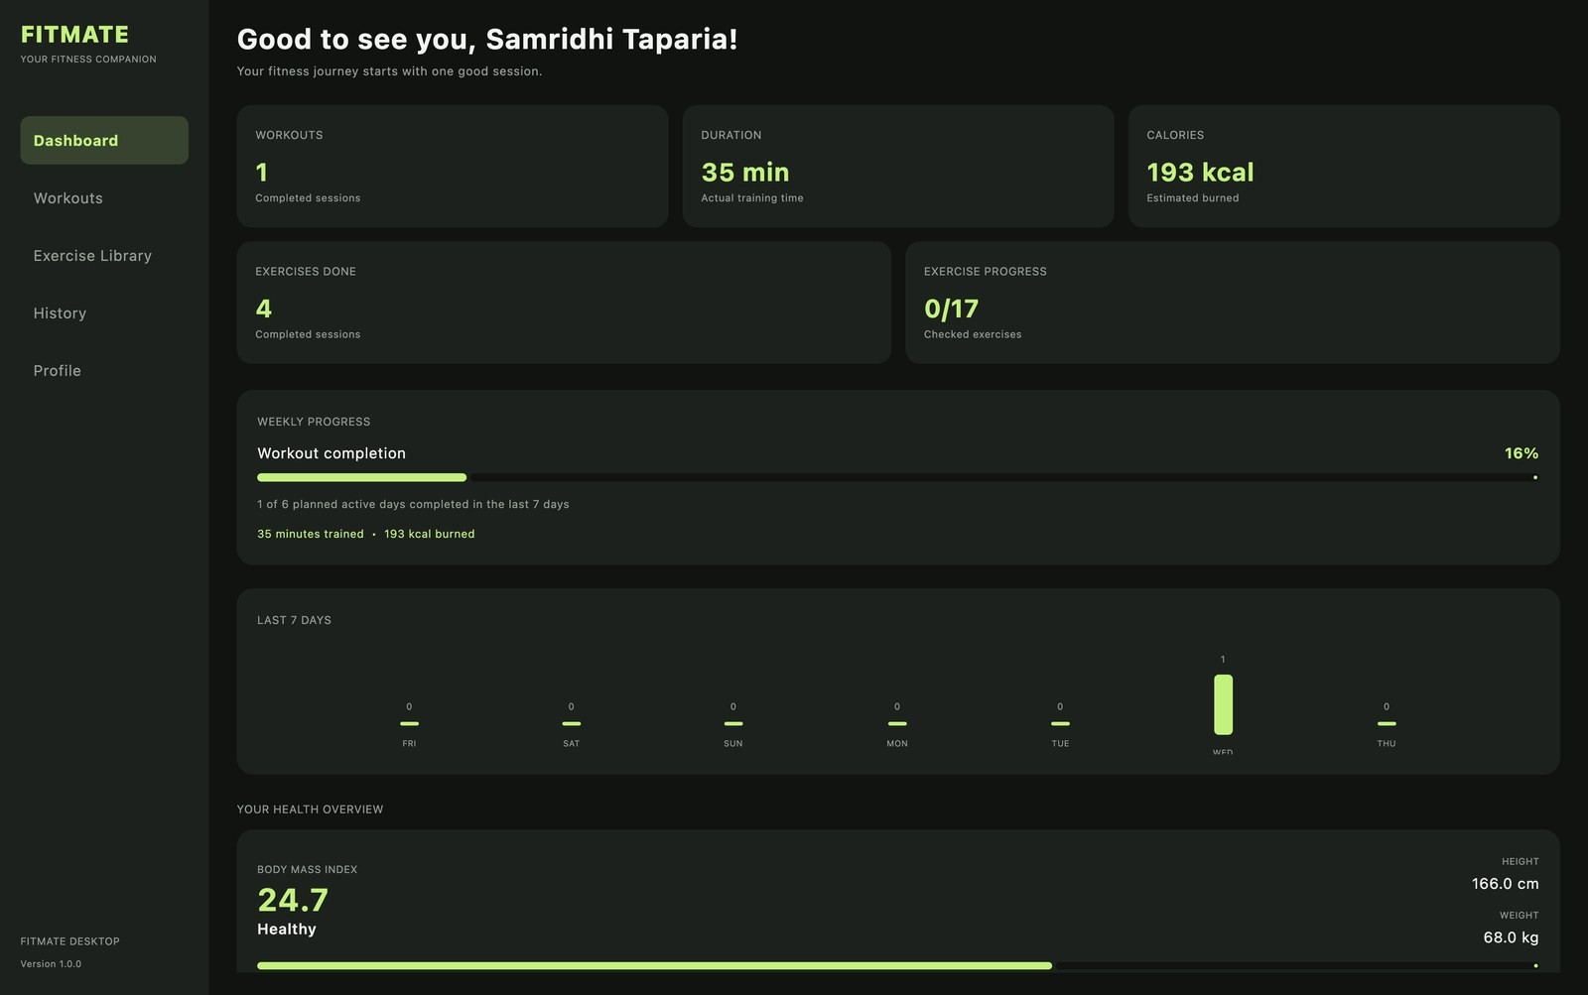
Figure 8.2 Desktop dashboard: workouts, duration, calories, weekly progress and BMI
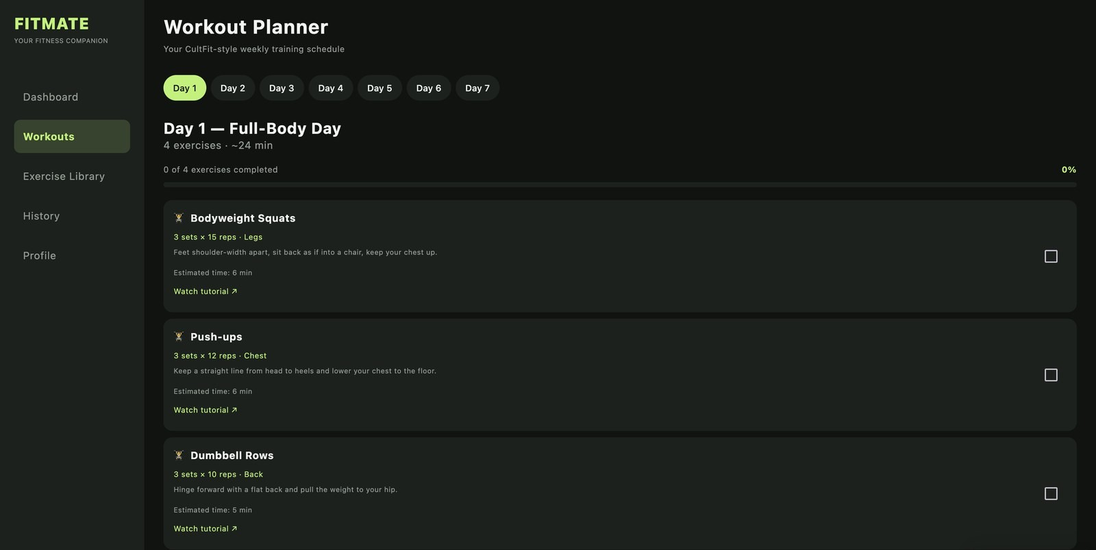
Figure 8.3 Desktop workout planner: Day 1 — Full-Body Day with checkboxes for each exercise
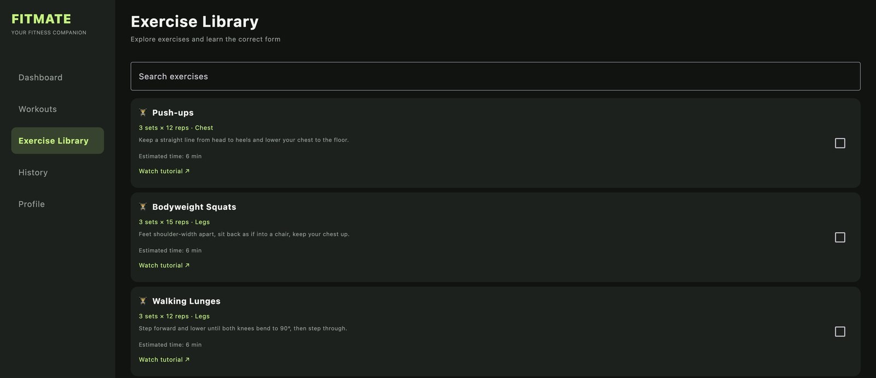
Figure 8.4 Desktop exercise library with search, form tips and tutorial links
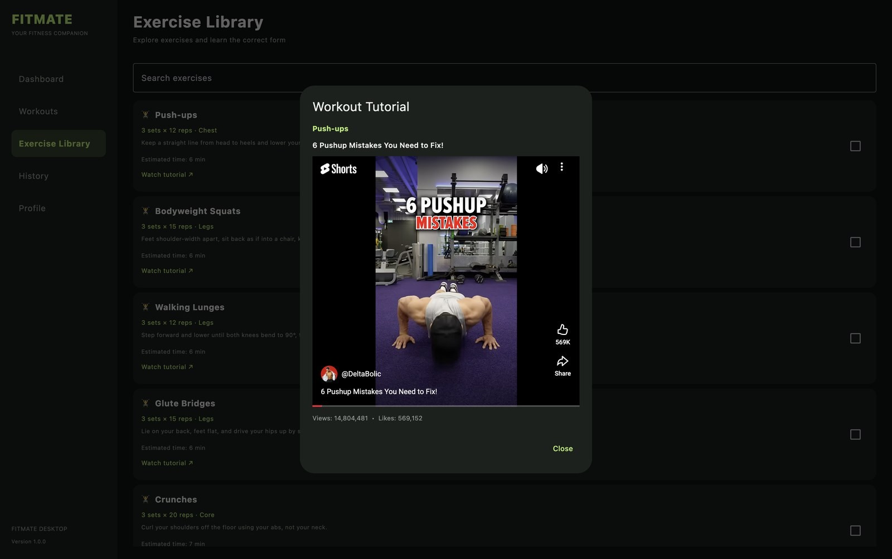
Figure 8.5 Tutorial video playing inside the desktop app, chosen by the backend's ranking
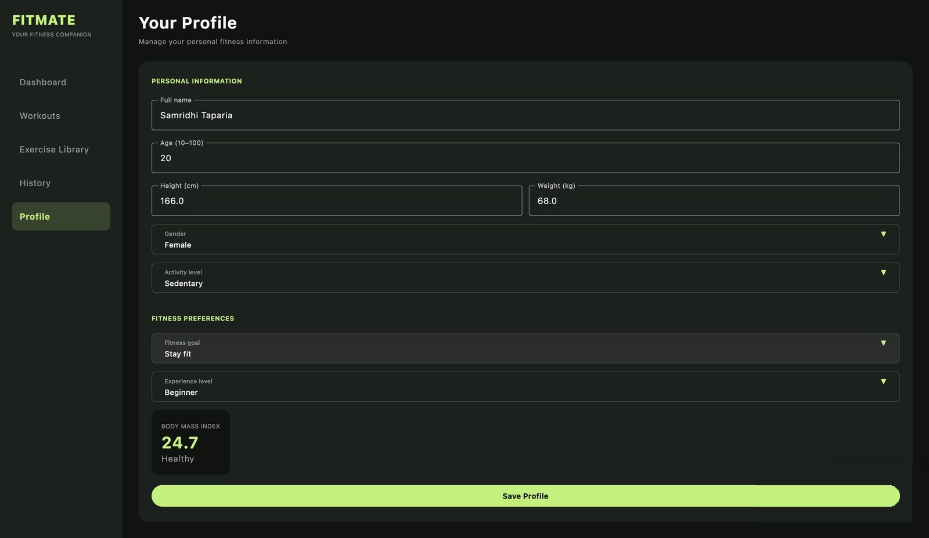
Figure 8.6 Desktop profile screen with live BMI
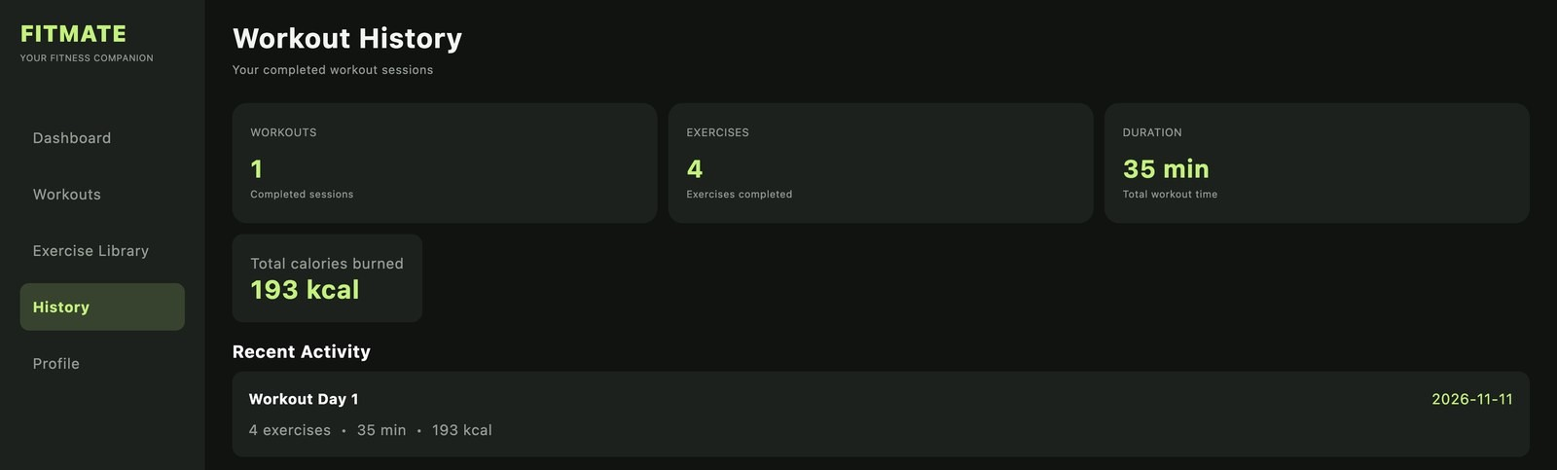
Figure 8.7 Desktop workout history

9 Testing
Because the logic lives in small classes with no Android code inside them, it can be tested with plain JUnit tests that run on a computer in seconds. The backend ranking is tested with pytest.
Running the tests
cd android && ./gradlew testDebugUnitTest # Android unit tests
cd backend && pytest # backend tests

Table 9.1 Android unit tests (DomainTest.kt)
# | Test | What it checks
1 | bmiIsComputedFromHeightAndWeight | BMI formula gives the right value
2 | impossibleWeightIsRejected | Constructor throws for an out-of-range weight
3 | setterAlsoValidates | Changing a field later is also validated
4 | hiitIsACardioExerciseAndBurnsMore | Inheritance and the 15% afterburn override
5 | scaledForKeepsTheSubclassAndAddsVolume | Scaling keeps the subclass type and adds sets
6 | ofTypeUsesTheClassHierarchy | Generic filter includes HIIT under cardio
7 | everyHealthMetricProducesText | All six metrics return a value and an explanation
8 | factoryPicksTheStrategyForTheGoal | Factory returns the right strategy for each goal
9 | everyGoalGetsASevenDayPlan | Every plan has exactly seven sessions
10 | streakCountsConsecutiveDays | Streak counting in WorkoutStats
11 | newUserIsNudgedToLogFirstWorkout… | First-workout tip appears; tips are sorted
12 | everyExerciseHasAYouTubeLink | No exercise is missing a tutorial link
13 | scaledExerciseKeepsItsVideoLink | Scaling does not lose the video link
14 | planIsNumberedDay1ToDay7WithClearDayNames | Days are numbered and named correctly

Table 9.2 Backend tests (test_ranking.py)
# | Test | What it checks
1 | test_best_tutorial_is_ranked_first | The highest-scoring video comes first
2 | test_non_embeddable_tutorial_is_excluded | Videos that cannot play in the app are removed
3 | test_rejected_tutorial_is_skipped | Videos the user disliked are not shown again
4 | test_missing_like_count_does_not_break_ranking | Weights are rescaled when a signal is missing
5 | test_all_rejected_returns_empty_list | Empty result is handled safely

10 Installation and Running
Table 10.1 How to build and run each part
Part | Requirements | Steps
Android | Android Studio, JDK | Open the android folder, let Gradle sync, press Run. Debug APK: ./gradlew assembleDebug.
iOS | macOS, Xcode | Open ios/FitMate.xcodeproj, choose an iOS 16+ simulator, press Run.
Desktop | JDK, Gradle | Run from the desktop folder. The first launch downloads dependencies and the JCEF runtime.
Backend | Python 3, YouTube API key | Create a virtual environment, pip install -r requirements.txt, put the key in backend/.env, start with uvicorn app.main:app --reload.

The backend runs at http://127.0.0.1:8000, with interactive API documentation at /docs. An Android emulator reaches it at 10.0.2.2; a real phone needs the computer's local IP address on the same Wi-Fi network.
Table 10.2 Backend API endpoints
Method | Endpoint | Purpose
GET | /tutorials/search?exercise=… | Search YouTube, rank the results and return the best tutorial
POST | /tutorials/feedback | Save a like or dislike so rejected videos are skipped next time
GET | /health | Check that the server is running

11 Privacy and Security
- No login and no cloud. The profile, workout history and reminders are stored only on the device.
- Only the exercise name leaves the phone when a tutorial is requested — never personal or health data.
- API keys are kept out of the code. The YouTube key lives in backend/.env, which is listed in .gitignore.
- Validated input on both sides: UserProfile checks every value, and FastAPI checks every request parameter with Pydantic.
- For a public deployment the backend should be served over HTTPS.

Note
Health numbers in FitMate are general guidance based on standard formulas. They are not medical advice.

12 Conclusion and Future Work

12.1 What we built
- FitMate for Android, iOS and desktop, with a Python FastAPI backend for tutorials.
- Every main OOP concept is used in a real feature, not a separate example.
- Strategy and Factory made the plan code easy to extend: a new goal is one new class.
- 19 automated tests check the core logic of the app and the backend.

12.2 What we learned
- Plan the classes before writing the screens.
- Small classes with one job are easier to understand, test and share between platforms.
- Depending on interfaces (Repository<T>, ReminderScheduler) let us change storage or alarms without touching the UI.

12.3 Future work
Table 12.1 Possible improvements
Idea | Benefit
Optional cloud backup | Move data to a new phone without losing history
Step counter and wearable support | Track daily activity automatically
Progressive overload | Increase sets or reps as the user gets stronger
Meal and nutrition log | Compare calories eaten with the daily target
Pose detection with the camera | Check exercise form in real time

References
[1] FitMate project repository. github.com/shivang-raj/FitMate
[2] Kotlin documentation — Classes, inheritance, interfaces and generics. kotlinlang.org/docs
[3] Android Developers — Jetpack Compose and app architecture guide. developer.android.com
[4] Apple Developer — SwiftUI documentation. developer.apple.com/documentation/swiftui
[5] FastAPI documentation. fastapi.tiangolo.com
[6] YouTube Data API v3 reference. developers.google.com/youtube/v3
[7] Gamma, E., Helm, R., Johnson, R. and Vlissides, J. (1994). Design Patterns: Elements of Reusable Object-Oriented Software. Addison-Wesley.
[8] Mifflin, M. D., St Jeor, S. T. et al. (1990). A new predictive equation for resting energy expenditure in healthy individuals. American Journal of Clinical Nutrition, 51(2), 241–247.
[9] Ainsworth, B. E. et al. (2011). Compendium of Physical Activities: a second update of codes and MET values. Medicine & Science in Sports & Exercise, 43(8), 1575–1581.

